
NATIONAL INSTITUTE OF TECHNOLOGY PUDUCHERRY
(An Institution of National Importance under MHRD, Govt. of India)
KARAIKAL – 609 609

DEPARTMENT OF COMPUTER SCIENCE AND ENGINEERING
Roll Number: | CS19B1016 | Name | BOYINA AJAY SANTHOSH
Semester: | II | Class: | B TECH 1ST YEAR
Subject Code: | CS106 | Subject Name: | DATA STRUCTURES LABORATORY

5.1 SINGLY LINKED LISTS
Date:20.2.20

AIM:

To IMPLEMENT LINKED LISTS BY USING C PROGRAM.

ALGORITHM:
1. Start the program.
2. Create the new data type “struct node”.
3. In struct node ,declare the variables data and next(node pointer).
4. Call the struct node as ‘nd’ by using typedef.
5.enter into main program.
6. Declare struct node pointer head,temp etc.
7. At starting, apply insert_first since there r no nodes.
8. Now apply insert_last node since there is one node and
lastnode->next=NULL
9.Now apply insert_posnode since there r two nodes.
10. after applying many insertions, apply delete_firstnode.
11.We can calculate no. of nodes through count and it also helps to
determine whether position is invalid or not.
12.Use display function to get the display of all datas present in node as well as the value of head(pointer to first node).
13. close the program.
.

PROGRAM:

#include<stdio.h>
#include<string.h>
#include<stdlib.h>
struct node
{
int data;
struct node *next;
};
int count=0;
typedef struct node nd;
nd *insert_firstnode(nd *,nd *);
nd *insert_posnode(nd *,nd *);
nd *insert_lastnode(nd *,nd *);
nd *delete_firstnode(nd *);
nd *delete_posnode(nd *);
nd *delete_lastnode(nd *);
void display(nd *);
int main()
{
nd *head;
nd *newnode;
nd *temp;
int choice;
head=NULL;
int ch;
printf("1.insert first 2.insert last 3.insert at any position\n");
printf("4. delete first 5.delete last 6.delete any position node 7.display\n");
do
{
printf("enter ch\n");
scanf("%d",&ch);
switch(ch)
{
case 1:
newnode=(nd *)malloc(sizeof(nd));
printf("insert data\n");
scanf("%d",&newnode->data);
head=insert_firstnode(head,newnode);
printf("the data is %d at 1st node\n",newnode->data);
break;
case 2:
newnode=(nd *)malloc(sizeof(nd));
printf("insert data\n");
scanf("%d",&newnode->data);
head=insert_lastnode(head,newnode);
printf("the data inserted at last node is %d\n",newnode->data);
break;
case 3:
newnode=(nd *)malloc(sizeof(nd));
printf("insert data\n");
scanf("%d",&newnode->data);
head=insert_posnode(head,newnode);
break;
case 4:
head=delete_firstnode(head);
break;
case 5:
head=delete_lastnode(head);
break;
case 6:
head=delete_posnode(head);
break;
case 7:
display(head);
break;
default:
printf("enter valid input\n");
}
}
while(ch!=0);
}
nd *insert_firstnode(nd *head,nd *newnode)
{
count++;
if(head==NULL)
{
newnode->next=NULL;
head=newnode;
}
else
{
newnode->next=head;
head=newnode;
}
return head;
}
nd *insert_lastnode(nd *head,nd *newnode)
{
nd *temp;
temp=head;
count++;
if(head==NULL)
{
insert_firstnode(head,newnode);
}
else if(head->next==NULL)
{
temp->next=newnode;
newnode->next=NULL;
}
else
{
while(temp->next!=NULL)
{
temp=temp->next;
}
temp->next=newnode;
newnode->next=NULL;
}
return head;
}
nd *insert_posnode(nd *head,nd *newnode)
{
nd *temp;
temp=head;
count++;
int pos,i=1;
printf("enter position\n");
scanf("%d",&pos);
if(pos>count)
{
printf("invalid position\n");
}
else
{
while(i<pos-1)
{
temp=temp->next;
i++;
}
newnode->next=temp->next;
temp->next=newnode;
}
printf("the data inserted at %d node is %d\n",pos,newnode->data);
return head;
}
nd *delete_firstnode(nd *head)
{
nd *temp;
temp=head;
count--;
if(head==NULL)
{
printf("empty linked list\n");
}
else if(head->next==NULL)
{
head=NULL;
printf("deleted node has %d data\n",temp->data);
free(temp);
}
else
{
head=temp->next;
printf("%d is data for deleted node\n",temp->data);
free(temp);
}
return head;
}
nd *delete_lastnode(nd *head)
{
nd *temp,*t1;
temp=head;
count--;
if(head==NULL)
{
printf("linked list is empty\n");
}
else
{
while(temp->next!=NULL)
{
t1=temp;
temp=temp->next;
}
t1->next=NULL;
printf("%d is data for deleted node\n",temp->data);
free(temp);
}
return head;
}
nd *delete_posnode(nd *head)
{
nd *temp,*t1;
temp=head;
int pos,i=1;
printf("enter position\n");
scanf("%d",&pos);
if(pos>count)
{
printf("invaid position\n");
}
else
{
while(i<pos-1)
{
temp=temp->next;
i++;
}
t1=temp->next;
temp->next=t1->next;
printf("%d is data of deleted node\n",t1->data);
free(t1);
}
count--;
return head;
}
void display(nd *head)
{
nd *temp;
temp=head;
while(temp!=0)
{
printf("%d\t",temp->data);
temp=temp->next;
}
printf("\n");
printf("%d\n",head);
}

OUTPUT:

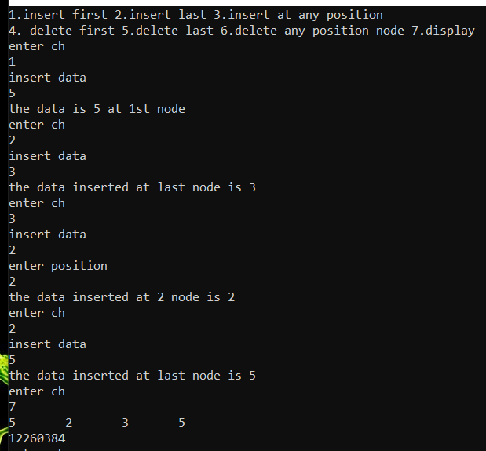

12260384 denotes head value.

RESULT:

The program is successfully executed.

5.2 CIRCULAR LINKED LIST
AIM:

To IMPLEMENT CIRCULAR LINKED LISTS BY USING C PROGRAM.

ALGORITHM:
1. Start the program.
2. Create the new data type “struct node”.
3. In struct node ,declare the variables data and next(node pointer).
4. Call the struct node as ‘nd’ by using typedef.
5.enter into main program.
6. Declare struct node pointer head,temp etc.
7. At starting, apply insert_first since there r no nodes.
8. Now apply insert_last node since there is one node but
lastnode->next=head
9.Now apply insert_posnode since there r two nodes.
10. after applying many insertions, apply delete_firstnode.
11.We can calculate no. of nodes through count and it also helps to
determine whether position is invalid or not.
12.Use display function to get the display of all datas present in node as well as the value of head(pointer to first node).
13. close the program.

PROGRAM:

#include<stdio.h>
#include<stdlib.h>
struct node
{
int data;
struct node *next;
};
typedef struct node nd;
nd *insert_firstnode(nd *,nd *);
nd *insert_posnode(nd *,nd *);
nd *insert_lastnode(nd *,nd *);
nd *delete_firstnode(nd *);
nd *delete_posnode(nd *);
nd *delete_lastnode(nd *);
void display(nd *);
int count=0;
int main()
{
nd *head,*newnode;
head=NULL;
int ch;
printf("1.insert first 2.insert last 3.insert at any position\n");
printf("4. delete first 5.delete last 6.delete any position node 7.display\n");
do
{
printf("enter ch\n");
scanf("%d",&ch);
switch(ch)
{
case 1:
newnode=(nd *)malloc(sizeof(nd));
printf("insert data\n");
scanf("%d",&newnode->data);
head=insert_firstnode(head,newnode);
printf("the data is %d at 1st node\n",newnode->data);
break;
case 2:
newnode=(nd *)malloc(sizeof(nd));
printf("insert data\n");
scanf("%d",&newnode->data);
head=insert_lastnode(head,newnode);
printf("the data inserted at last node is %d\n",newnode->data);
break;
case 3:
newnode=(nd *)malloc(sizeof(nd));
printf("insert data\n");
scanf("%d",&newnode->data);
head=insert_posnode(head,newnode);
break;
case 4:
head=delete_firstnode(head);
break;
case 5:
head=delete_lastnode(head);
break;
case 6:
head=delete_posnode(head);
break;
case 7:
display(head);
break;
default:
printf("enter valid input\n");
}
}while(ch!=0);
}
nd *insert_firstnode(nd *head,nd *newnode)
{
nd *temp,*t1;
temp=head;
t1=head;
if(head==NULL)
{
newnode->next=newnode;
head=newnode;
}
else if(head->next==head)
{
newnode->next=temp;
temp->next=newnode;
head=newnode;
}
else
{
newnode->next=temp;
head=newnode;
while(t1->next!=head)
{
t1=t1->next;
}
t1->next=newnode;
}
count++;
return head;
}
nd *insert_lastnode(nd *head,nd *newnode)
{
nd *temp,*t1;
temp=head;
t1=head;
if(head==NULL)
{
insert_firstnode(head,newnode);
}
else if(head->next==head)
{
temp->next=newnode;
newnode->next=temp;
}
else
{
while(t1->next!=head)
{
t1=t1->next;
}
t1->next=newnode;
newnode->next=head;
}
count++;
return head;
}
nd *insert_posnode(nd *head,nd *newnode)
{
nd *temp;
temp=head;
count++;
int pos,i=1;
printf("enter position\n");
scanf("%d",&pos);
if(pos>count)
{
printf("invalid position\n");
}
else
{
while(i<pos-1)
{
temp=temp->next;
i++;
}
newnode->next=temp->next;
temp->next=newnode;
}
printf("the data inserted at %d node is %d\n",pos,newnode->data);
count++;
return head;
}
nd *delete_firstnode(nd *head)
{
nd *temp,*t1,*t2;
temp=head;
t1=head;
t2=head;
if(head==NULL)
{
printf("ll is empty\n");
}
else if(head->next==head)
{
head=NULL;
printf("deleted node has %d data\n",temp->data);
free(temp);
}
else
{
t1=t1->next;
while(temp->next!=head)
{
temp=temp->next;
}
temp->next=t1;
head=t1;
printf("deleted node has %d data\n",t2->data);
free(t2);
}
count--;
return head;
}
nd *delete_lastnode(nd *head)
{
nd *t1,*t2,*temp;
t1=head;
t2=head;
temp=head;
if(head==NULL)
{
printf("ll is empty\n");

}
else if(head->next==head)
{
delete_firstnode(head);
}
else
{
t1=t1->next;
while(temp->next!=head)
{
temp=temp->next;
}
t1->next=head;
printf("deleted node has %d data\n",temp->data);
free(temp);
}
count--;
return head;
}
nd *delete_posnode(nd *head)
{
nd *temp,*t1;
temp=head;
int pos,i=1;
printf("enter position\n");
scanf("%d",&pos);
if(pos>count)
{
printf("invaid position\n");
}
else
{
while(i<pos-1)
{
temp=temp->next;
i++;
}
t1=temp->next;
temp->next=t1->next;
printf("%d is data of deleted node\n",t1->data);
free(t1);
}
count--;
return head;
}
void display(nd *head)
{
nd *temp;
temp=head;
while(temp->next!=head)
{
printf("%d\t",temp->data);
temp=temp->next;
}
printf("%d\t",temp->data);
printf("\n");
printf("head=%d\n",head);
}

OUTPUT:

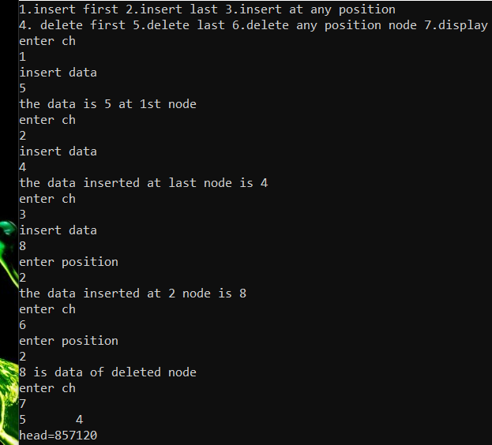

RESULT:

The program is successfully executed.

5.3 DOUBLY LINKED LIST
AIM:
To implement doubly linked list program through c language.

ALGORITHM:
1. Start the program.
2. Create the new data type ‘struct node’
3. In struct node, declare the variables data(int) & struct node pointer ‘next’ & ‘prev’.
4. the ‘next’ pointer stores the address of next node and ‘ prev’
stores the address of previous node.
5. Name the struct node as nd by using typedef.
6. enter into main program.
7. Declare head,temp etc.,
8. At starting,apply insert_first node since there r no nodes.
9. Now apply insert_last node since there is one node but lastnode->next must be equal to null.
10. Now apply insert pos_node since there r two nodes.
11. after many insertions, apply remove_first or remove_last or
remove_pos node.
12. Declare the integer variable count.( to calculate the number of nodes)
13. BY using count, we can determine whether our insertion or deletion position is valid or not.
14. DISPLAY : it is used to display all the data present in nodes and to print the value of head.
15. close the program.

PROGRAM:
#include<stdio.h>
#include<stdlib.h>
struct node
{
int data;
struct node *next;
struct node *prev;
};
typedef struct node nd;
nd *insert_firstnode(nd *,nd *);
nd *insert_posnode(nd *,nd *);
nd *insert_lastnode(nd *,nd *);
nd *delete_firstnode(nd *);
nd *delete_posnode(nd *);
nd *delete_lastnode(nd *);
nd *display(nd *);
void number();
void reversedoubly(nd *);
int count=0;
int main()
{
nd *head,*newnode;
head=NULL;
int ch;
printf("1.insert_first 2.insert_last 3.insert_pos\n");
printf("4.delete_first 5.delete_last 6.delete_pos 7.display\n");
do
{
scanf("%d",&ch);
switch(ch)
{
case 1:
newnode=(nd *)malloc(sizeof(nd));
printf("insert data\n");
scanf("%d",&newnode->data);
head=insert_firstnode(head,newnode);
printf("the data is %d at 1st node\n",newnode->data);
break;
case 2:
newnode=(nd *)malloc(sizeof(nd));
printf("insert data\n");
scanf("%d",&newnode->data);
head=insert_lastnode(head,newnode);
printf("the data inserted at last node is %d\n",newnode->data);
break;
case 3:
newnode=(nd *)malloc(sizeof(nd));
printf("insert data\n");
scanf("%d",&newnode->data);
head=insert_posnode(head,newnode);
break;
case 4:
head=delete_firstnode(head);
break;
case 5:
head=delete_lastnode(head);
break;
case 6:
head=delete_posnode(head);
break;
case 7:
head=display(head);
break;
case 8:
number( );
break;
default:
printf("enter valid input\n");
}
}while(ch!=0);
reversedoubly(head);
}
nd *insert_firstnode(nd *head,nd *newnode)
{
nd *temp,*t1;
temp=head;
if(head==NULL)
{
newnode->prev=NULL;
newnode->next=NULL;
head=newnode;
}
else if(head->next==NULL)
{
newnode->prev=NULL;
newnode->next=temp;
temp->prev=newnode;
head=newnode;
}
else
{
newnode->prev=NULL;
newnode->next=temp;
temp->prev=newnode;
head=newnode;
}
count++;
return head;
}
nd *insert_lastnode(nd *head,nd *newnode)
{
nd *temp,*t1;
temp=t1=head;
if(head==NULL)
{
insert_firstnode(head,newnode);
}
else if(head->next==NULL)
{
newnode->prev=temp;
newnode->next=NULL;
temp->next=newnode;
}
else
{
while(t1->next!=NULL)
{
t1=t1->next;
}
newnode->prev=t1;
newnode->next=NULL;
t1->next=newnode;
}
count++;
return head;
}
nd *insert_posnode(nd *head,nd *newnode)
{
nd *temp,*t1,*t2;
int i=1;
temp=head;
t1=head;
int pos;
printf("enter position\n");
scanf("%d",&pos);
if(pos>count)
{
printf("invalid position\n");
}
else
{
while(i<pos-1)
{
t1=t1->next;
i++;
}
t2=t1->next;
newnode->next=t1->next;
t1->next=newnode;
newnode->prev=t1;
t2->prev=newnode;
printf("%d element is inserted at %d node\n",newnode->data,pos);
}
count++;
return head;
}
nd *delete_firstnode(nd *head)
{
nd *temp,*t1;
temp=t1=head;
if(head==NULL)
{
printf("ll is empty\n");
}
else if(head->next==NULL)
{
head=NULL;
printf("DELETED NODE HAS:\n");
printf("%d-data\n",temp->data);
free(temp);
}
else
{
t1=t1->next;
t1->prev=NULL;
head=t1;
printf("DELETED NODE HAS:\n");
printf("%d-data\n",temp->data);
free(temp);
}
count--;
return head;
}
nd *delete_lastnode(nd *head)
{
nd *temp,*t1,*t2;
temp=head;
t1=head;
t2=head;
if(head==NULL)
{
printf("ll is empty\n");
}
else if(head->next==NULL)
{
delete_firstnode(head);
}
else
{
while(t1->next!=NULL)
{
t1=t1->next;
}
t2=t1->prev;
t2->next=NULL;
printf("DELETED NODE HAS:\n");
printf("%d-data\n",t1->data);
free(t1);
}
count--;
return head;
}
nd *delete_posnode(nd *head)
{
nd *temp,*t1,*t2;
int pos,i=1;
printf("enter pos\n");
scanf("%d",&pos);
temp=t1=t2=head;
if(pos>count)
{
printf("invalid position\n");
}
else
{
while(i<pos-1)
{
temp=temp->next;
}
t1=temp->next;
t2=t1->next;
temp->next=t2;
t2->prev=temp;
printf("%d element is deleted at %d position\n",t1->data,pos);
free(t1);
}
count--;
return head;
}
nd *display(nd *head)
{
nd *temp;
temp=head;
while(temp!=NULL)
{
printf("%d\t",temp->data);
temp=temp->next;
}
printf("\n");
printf("head=%d\n",head);
return head;
}
void number( )
{
printf("no. of nodes present=%d\n",count);
}
void reversedoubly(nd *head)
{
nd *temp,*t1;
temp=head;
while(temp->next!=NULL)
{
temp=temp->next;
}
head=temp;
t1=head;
while(t1!=NULL)
{
printf("node has %d data and %d next and %d prev\n",t1->data,t1->prev,t1->next);
t1=t1->prev;
}
}

OUTPUT:

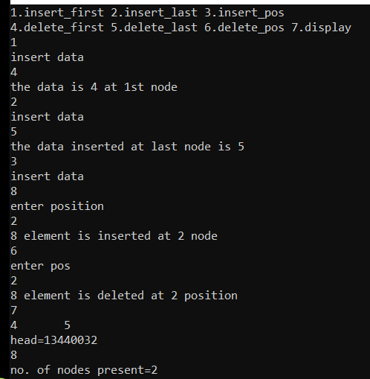

RESULT:

The program is successfully executed.

